**Crypto Bank - A Decentralized Blockchain Application**

Submitted in partial fulfillment of the requirements of the degree

**BACHELOR OF ENGINEERING IN ARTIFICIAL INTELLIGENCE AND DATA SCIENCE**

By

**1. Sachin Bade (02 / 211101003)**

**2. Vedant Bhosale (06 / 211101051)**

**3. Naresh Chaudhary (09 / 211101053)**

**4. Yash Shirsath (65 / 201101006)**

**Project Guide**

**Prof. Bhagyashri Kulkarni**



**Department of Artificial Intelligence &**

**Data Science**

**A. C. Patil College of Engineering**

**Kharghar, Navi Mumbai**

**University of Mumbai**

**(AY 2024-25)**

**CERTIFICATE**

This is to certify that the Mini Project entitled

**CryptoBank**

is a Bonafide Work of

**Sachin Bade - 02**

**Vedant Bhosale - 06**

**Naresh Chaudhary - 09**

**Yash Shirsath - 65**

Submitted to the **University of Mumbai** in partial fulfillment of the requirement for the award of the Degree of **“Bachelor of Engineering”** in **“Artificial Engineering and Data Science”.**

**Prof. Bhagyashri Kulkarni**

**(Project Guide)**

**Prof. Shilpali P. Bansu Dr. V. N. Pawar**

(**Head of Department)** (**Principal)**

**Mini Project Approval**

This Mini Project Entitled **“CryptoBank” by** **Sachin Bade** (2), **Vedant Bhosale** (06), **Naresh Chaudhary** (09), **Yash Shirsath** (65) is Approved for the Degree of Bachelor of Engineering inArtificial Intelligence and Data Science.

**Examiners**

**1………………………………………**

(Internal Examiner Name & Sign)

**2………………………………………**

(External Examiner name & Sign)

**Date:** 17/10/2024

**Place**: A. C. Patil College of Engineering, Kharghar

**Contents**

**Abstract**

**Acknowledgements List of Figures**

**List of Tables**

1] Introduction 8

* 1. Introduction
  2. Motivation
  3. Problem Statement & Objectives
  4. Organization of the Report

2] Literature Survey 10

* 1. Survey of Existing System
  2. Limitation Existing system or research gap
  3. Mini Project Contribution

3] Proposed System 12

3.1. Introduction

3.2. Architecture/ Framework

3.3. Algorithm and Process Design

3.4. Details of Hardware & Software

3.5. Experiment and Results

3.6. Conclusion and Future work.

3.7. References

# Abstract

Blockchain technology is transforming industries, especially finance, by offering a decentralized, secure, and transparent way to manage data and transactions. **Crypto Bank** is a blockchain-based decentralized application (DApp) designed to showcase blockchain’s core functionalities in financial transactions. Unlike traditional banking systems that rely on centralized authorities for transaction processing, Crypto Bank operates on a peer-to-peer network, allowing users to engage in secure transactions without intermediaries. the project demonstrates key blockchain principles, including decentralization, immutability, security, and consensus. Using the Proof-of-Work (PoW) algorithm, Crypto Bank validates transactions and records them on a distributed public ledger, ensuring transparency and data integrity.

The backend, built with Flask, handles blockchain operations like block creation, mining, and validation, while the frontend, developed using React, enables users to interact with the blockchain, initiate transactions, and view the current blockchain status. Crypto Bank bridges the gap between blockchain theory and practice, serving as a valuable learning tool for enthusiasts. It also highlights the potential for applications like decentralized finance (DeFi) and secure record-keeping. Crypto Bank provides a practical platform to explore blockchain's potential in revolutionizing secure financial transactions.

**Acknowledgment**

We extend our heartfelt gratitude to our esteemed college Principal, Dr. V. N. Pawar, for his unwavering support in providing the essential resources for the development of this project. Special thanks go to our Head of the Department, Shilpali Bansu, for her invaluable suggestion of this impactful project topic for departmental purposes. we owe a great debt of thanks to our dedicated Project Guide, Prof. Bhagyashri Kulkarni, for her mentorship, expert guidance, and constant encouragement throughout this project's journey. Her insights and innovative ideas have been instrumental in the project's success. we would also like to express our appreciation to all the faculty members who have been a source of support, knowledge, and motivation during this endeavor. Additionally, our friends and families have played an immeasurable role in our lives, providing unwavering love, support, and understanding that have been our pillars of strength throughout this project. We are profoundly grateful for their presence in our lives. this acknowledgment reflects our sincere appreciation for the contributions and support we've received from everyone who has been part of our project's success.

Date: 17/10/2024

Sign:

**List of Figures**

|  |  |  |
| --- | --- | --- |
| **Sr. No.** | **Name of Picture** | **Page no.** |
| 1 | Architecture / Framework. | 12 |
| 2 | Welcome Page | 14 |
| 3 | Mining | 14 |
| 4 | Validation | 14 |
| 5 | Addition | 14 |
| 6 | Block Addition/Mining | 14 |
| 7 | Chaining | 15 |

**Chapter 1 – Introduction**

**1.1. Introduction**

Blockchain technology has rapidly emerged as one of the most revolutionary innovations of the 21st century. It has transformed the way data is stored, managed, and secured, particularly in the financial sector. Blockchain is a decentralized, distributed ledger system that enables secure, transparent, and tamper-proof transactions without the need for intermediaries such as banks or financial institutions. the **Crypto Bank** project aims to demonstrate the fundamental principles and workings of blockchain technology in the context of a decentralized financial application. By leveraging blockchain, Crypto Bank allows users to conduct secure transactions in a peer-to-peer network without relying on a centralized authority.

Unlike traditional banking systems, which depend on a central entity to process and validate transactions, Crypto Bank operates through a consensus mechanism. Transactions are validated by network participants, recorded on a public ledger, and secured using cryptographic techniques. This ensures that the transaction data is immutable, transparent, and cannot be tampered with. this project introduces students and developers to the core aspects of blockchain technology, including decentralization, security, consensus algorithms, and transparency. Through practical implementation, Crypto Bank aims to bridge the gap between theoretical blockchain concepts and their real-world applications in the financial domain.

**1.2. Motivation**

The increasing prominence of blockchain technology, particularly in the financial sector, has sparked significant interest in exploring its potential applications. Traditional banking systems rely heavily on centralized authorities, which can introduce inefficiencies, high costs, and security vulnerabilities. The decentralized nature of blockchain offers a promising alternative by enabling secure, transparent, and tamper-proof financial transactions without intermediaries. the motivation behind the **Crypto Bank** project stems from the desire to harness the advantages of blockchain technology in creating a decentralized financial system. With blockchain, transactions can be conducted directly between participants, eliminating the need for a third party, reducing transaction costs, and enhancing security. Moreover, blockchain’s inherent transparency ensures that all transactions are verifiable and immutable, promoting trust and accountability.

As students, the motivation for developing Crypto Bank was to gain hands-on experience in building a real-world decentralized application (DApp). The project serves as a learning platform to understand blockchain fundamentals, such as consensus algorithms (Proof-of-Work), mining, and block validation. Additionally, the practical experience of integrating blockchain with web technologies like Flask and React allows for a deeper comprehension of how blockchain can be applied to real-world problems.

**1.3. Problem Statement and Objective**

* **Problem Statement**: - Traditional banking systems operate on centralized models, relying on trusted intermediaries such as banks or financial institutions to facilitate and validate transactions. This centralized approach comes with inherent challenges, including:-
* **High Transaction Costs**:- The involvement of multiple intermediaries often leads to higher fees for processing transactions.
* **Security Risks**:- Centralized databases are vulnerable to hacking, fraud, and data breaches, putting user funds and sensitive information at risk.
* **Lack of Transparency**:- Users have limited visibility into the processes and operations of financial transactions, leading to trust issues.
* **Single Point of Failure**:- If the central authority or database fails, it can disrupt the entire system, causing widespread financial loss or transaction delays.

Given these challenges, there is a need for a decentralized financial system that provides transparency, security, and direct peer-to-peer transactions without reliance on a central authority.

* **Objective**: -

The **Crypto Bank** project aims to address the limitations of traditional banking systems by implementing a decentralized application (DApp) using blockchain technology. The key objectives of this project are:-

1. **Decentralized Transaction System**:- To create a platform where users can perform secure, peer-to-peer financial transactions without the need for intermediaries or centralized authorities.
2. **Immutability and Security**:- To ensure that all transactions recorded on the blockchain are immutable and cannot be altered, providing enhanced data integrity and security.
3. **Transparency**:- To offer users a transparent financial system where all transactions are visible on a publicly distributed ledger, promoting trust and accountability.
4. **Proof-of-Work (PoW) Consensus Mechanism**:- To implement the PoW algorithm to validate transactions, ensuring fairness and security in the process of mining and adding new blocks to the blockchain.
5. **Blockchain Exploration**:- To allow users to explore and interact with the blockchain through a user-friendly web interface, enabling them to mine blocks, view the blockchain, and validate transactions.
6. **Educational Tool**:- To provide a practical learning platform for students and developers to understand the fundamental concepts of blockchain technology and its real-world applications in finance.

By achieving these objectives, Crypto Bank demonstrates the practical utility of blockchain technology in creating a secure, transparent, and decentralized financial system.

**Chapter 2 - Literature Survey**

##### 

**2.1. Survey of Existing System**

#### **1.** **Centralized Banking Systems**: -

* **Overview**: - Traditional banking systems are controlled by a central authority, such as banks, which manage transactions, customer verification, and data storage.
* **Limitations**: -
* **Security Risks**: - Prone to cyber-attacks and single points of failure.
* **Lack of Transparency**: - Limited user visibility into transaction processes.
* **High Fees & Delays**: - Transaction costs and processing times are often high, especially for international transfers.

#### **2.** **Cryptocurrency Systems (e.g., Bitcoin, Ethereum)**: -

* **Overview**: Decentralized systems like Bitcoin and Ethereum enable peer-to-peer transactions using blockchain technology.
* **Limitations**:
* **Scalability**: - Slow transaction confirmation times with increased usage.
* **Energy Consumption**: - Pow mechanisms require HCP.
* **Volatility**: - Price fluctuations hinder use as stable financial systems.

#### **3**. **Digital Payment Platforms (e.g., PayPal, Venmo)**: -

* **Overview**: Centralized digital payment platforms offer faster online transactions but still rely on traditional financial infrastructure.
* **Limitations**:
* **Centralized Control**: - Prone to the same security and privacy risks as traditional systems.
* **Fees & Privacy**: - Fees for certain services and user data privacy concerns.

**2.2. Limitation Existing System or Research Gap**

Despite the advancements in existing financial systems, several limitations persist, revealing significant research gaps that **Crypto Bank** seeks to address:

1. **Centralization**:- Most traditional banking systems and digital payment platforms operate under centralized control, leading to vulnerabilities such as single points of failure, increased risk of fraud, and potential abuse of power.
2. **Lack of Transparency**:- Existing systems often lack transparency in transaction processes, which can lead to distrust among users. This opacity makes it difficult for customers to understand the true nature of their transactions and the fees involved.
3. **High Costs and Delays**:- Traditional banking and payment platforms impose high transaction fees and long processing times, especially for cross-border transactions. This inefficiency limits accessibility for many users, particularly in underbanked regions.
4. **Scalability Issues**:- Blockchain-based systems like Bitcoin face scalability challenges, resulting in slow transaction times during peak usage. Existing solutions struggle to process a high volume of transactions efficiently.
5. **Energy Consumption**:- Many cryptocurrency networks, particularly those using Proof-of-Work (PoW), consume vast amounts of energy, raising concerns about sustainability and environmental impact.
6. **Volatility**:- Cryptocurrencies are often subject to extreme price volatility, which can deter their use as stable mediums of exchange and stores of value.
7. **Regulatory Uncertainty**:- The evolving regulatory landscape around cryptocurrencies creates uncertainty for users and developers, hindering widespread adoption and innovation.

**Crypto Bank** aims to fill these gaps by leveraging decentralized blockchain technology to create a secure, transparent, and efficient financial system that minimizes costs, enhances user trust, and promotes accessibility for all.

##### 2.3. Mini Project Contribution

The **Crypto Bank** mini project significantly contributes to the understanding and practical application of blockchain technology in the financial sector. It provides students with hands-on learning experiences, allowing them to apply theoretical knowledge of blockchain and decentralized systems in a real-world context. By demonstrating how blockchain facilitates secure, peer-to-peer transactions without intermediaries, the project highlights the benefits of decentralization over traditional banking systems.

Moreover, it showcases the advantages of using cryptographic techniques and consensus algorithms to ensure data integrity and transparency in financial transactions, addressing concerns associated with existing systems. The implementation of a Proof-of-Work (PoW) algorithm for block validation and mining offers insights into blockchain consensus mechanisms and their impact on transaction validation. The project features an intuitive frontend developed with React, which enables users to interact easily with the blockchain, initiate transactions, mine blocks, and view the blockchain status, thereby enhancing user engagement and experience.

Additionally, the project identifies and analyses the limitations of existing financial systems, providing a basis for further research into potential applications of blockchain in various sectors, including finance, supply chain management, and digital asset management. By laying the groundwork for future enhancements and features, such as smart contracts and decentralized finance (DeFi) applications, **Crypto Bank** enables users to explore advanced functionalities within the blockchain ecosystem. In summary, this mini project serves not only as an educational tool for understanding blockchain principles but also as a source of valuable insights and practical solutions to address current challenges in financial transactions and systems.

**Chapter 3 - Proposed System**

**3.1. Introduction**

The **Crypto Bank** project introduces a decentralized application (DApp) designed to utilize blockchain technology for secure and transparent financial transactions. This system aims to overcome the limitations of traditional banking by enabling peer-to-peer transactions without intermediaries. key components of **Crypto Bank** include a Flask-powered backend that manages blockchain operations and a user-friendly frontend built with React for seamless interaction. The system supports essential functionalities such as transaction processing, block mining, and blockchain validation, ensuring data integrity through cryptographic techniques and consensus algorithms. this chapter will explore the architecture, processes, hardware and software requirements, and the contributions of the proposed system, highlighting its role in advancing the practical application of blockchain technology in the financial sector.

**3.2. Architecture/ Framework**

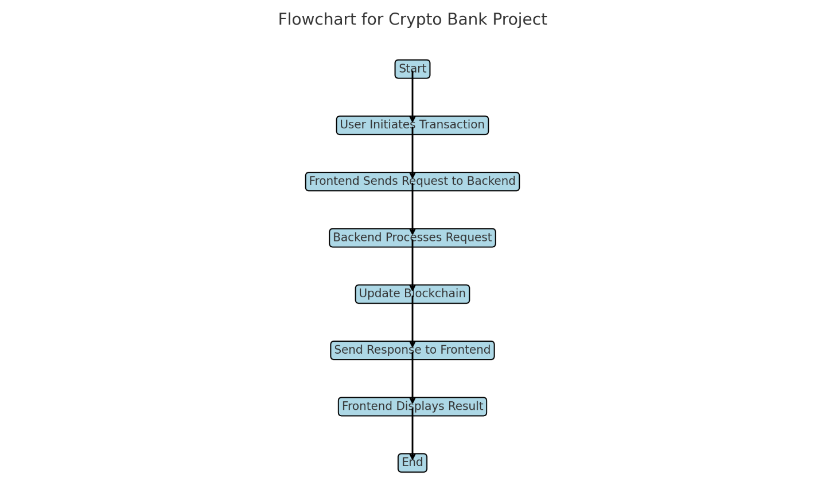

**Flowchart for CryptoBank Project**

**3.3. Algorithm and Process Design**

The Crypto Bank project employs a combination of algorithms and process designs that facilitate the core functionalities of a blockchain-based financial application. Below are the main components of the algorithm and the process design utilized in the system.

#### 1. **Blockchain Structure**

* **Data Structure**: Each block in the blockchain contains the following elements:
* **Index**: Position of the block in the blockchain.
* **Timestamp**: The time when the block was created.
* **Data**: The transaction data.
* **Previous Hash**: The hash of the previous block.
* **Hash**: The unique hash of the current block.

#### 2. **Hashing Function**

* **SHA-256 Algorithm**: A cryptographic hash function that transforms input data into a fixed-size string of characters, ensuring data integrity and security.
* **Process**: -
* Input the block's data and the previous block's hash.
* Generate the hash for the current block.

#### 3. **Mining Process**

* **Proof of Work (PoW)**: A consensus algorithm to validate transactions and create new blocks.
* **Process**:- Miners compete to solve a cryptographic puzzle by finding a nonce (a number used once). the first miner to find the correct nonce that produces a hash meeting the difficulty level adds the block to the blockchain.

#### 4. **Transaction Flow**

* **User Initiation**: Users initiate a transaction through the frontend interface.
* **Validation**: The backend verifies the transaction details, including the sender's balance and validity of the transaction.
* **Block Creation**: Valid transactions are added to a new block.
* **Mining**: The new block undergoes mining to be added to the blockchain.
* **Broadcasting**: The updated blockchain is broadcasted to all nodes in the network.

#### 5. **Transaction Validation**

* **Verification**: Each transaction is verified through a consensus mechanism to ensure it is legitimate and does not involve double spending.
* **Confirmation**: Once validated, the transaction is confirmed and included in the blockchain.

#### 6. **User Interface Interaction**

* **Frontend Communication**: The frontend communicates with the backend via RESTful API calls.
* **Response Handling**: The frontend handles responses from the backend, displaying transaction statuses and blockchain updates to users.

**3.4. Details of Hardware & Software**

#### Hardware Requirements: -

* **Processor**: Intel i5 or equivalent (minimum)
* **RAM**: 8 GB (minimum)
* **Storage**: Minimum 100 MB free disk space; SSD recommended for faster performance.
* **Network**: Internet connection for external access.

#### Software Requirements: -

* **Operating System**: Windows 10 or later, macOS, or Linux (Ubuntu 20.04 or later)
* **Backend**:
  + **Python**: Version 3.8 or later
  + **Flask**: Web framework for backend
* **Frontend**:
  + **Node.js**: Version 14 or later
  + **React**: Library for building user interfaces
* **Development Tools**:
  + **Visual Studio Code**: Code editor
  + **Postman**: For testing APIs
  + **Git**: For version control

These requirements will support the effective development and operation of the Crypto Bank application.

**3.5. Results**

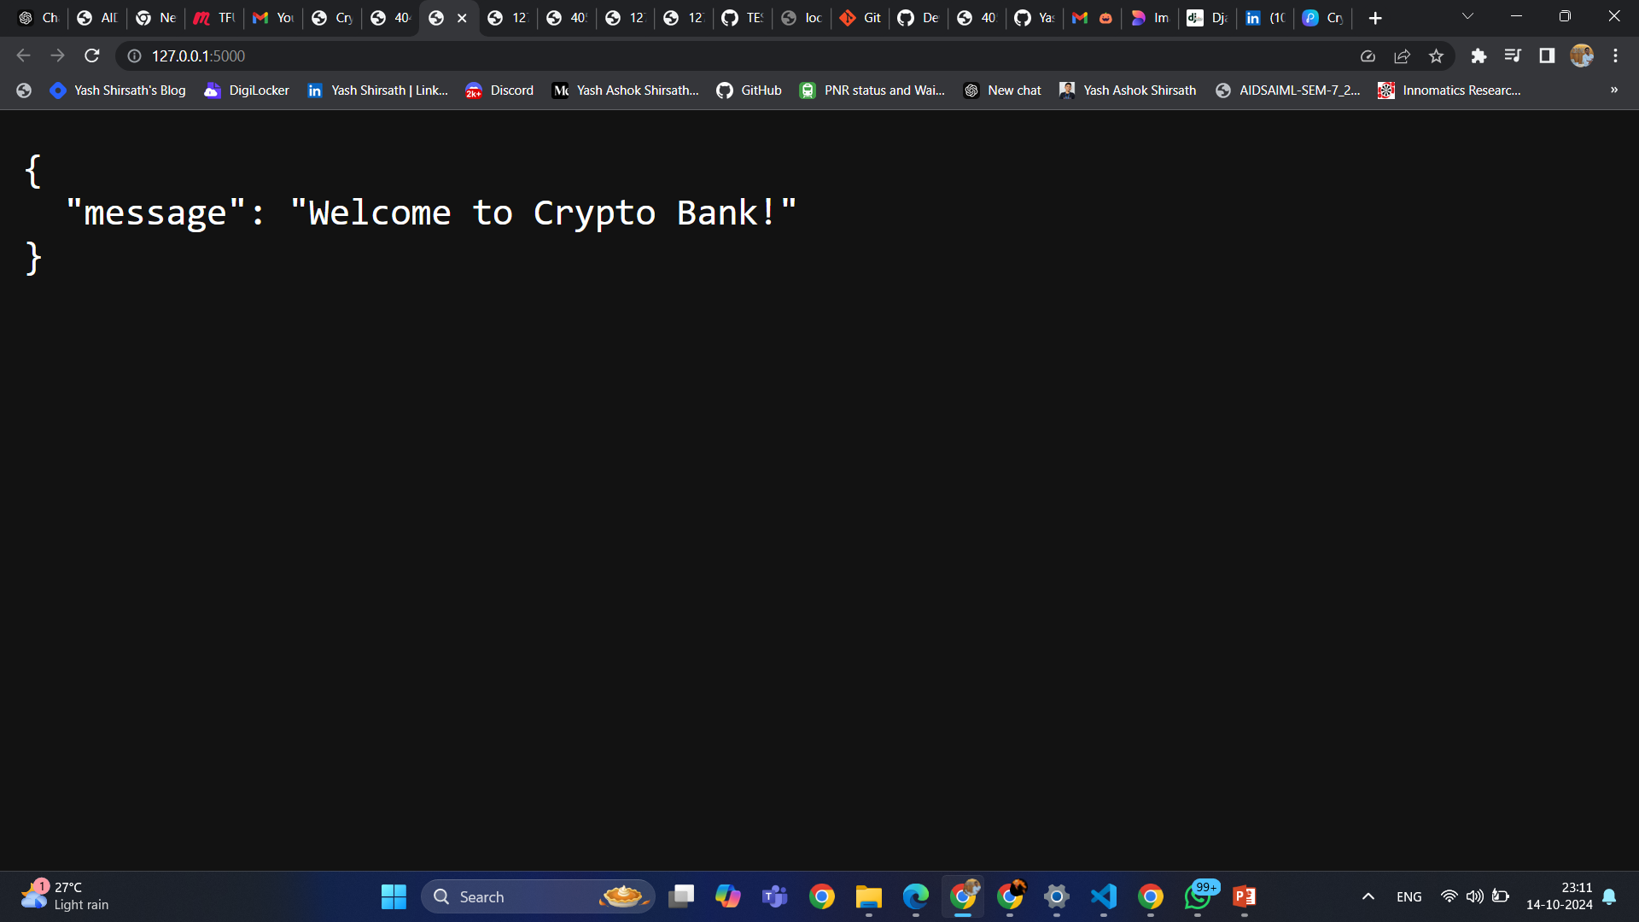

**Fig 1 - Welcome Page**

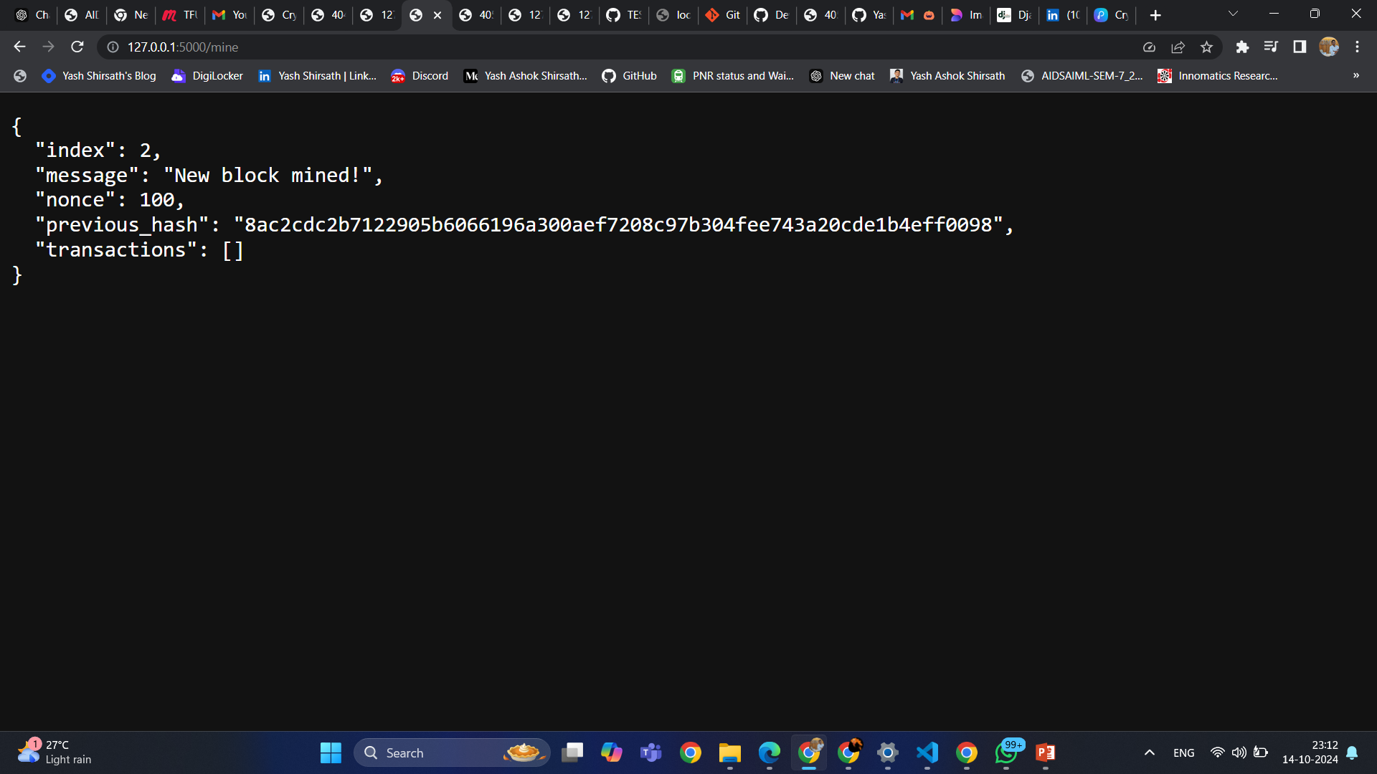

**Fig 2 - Mining**

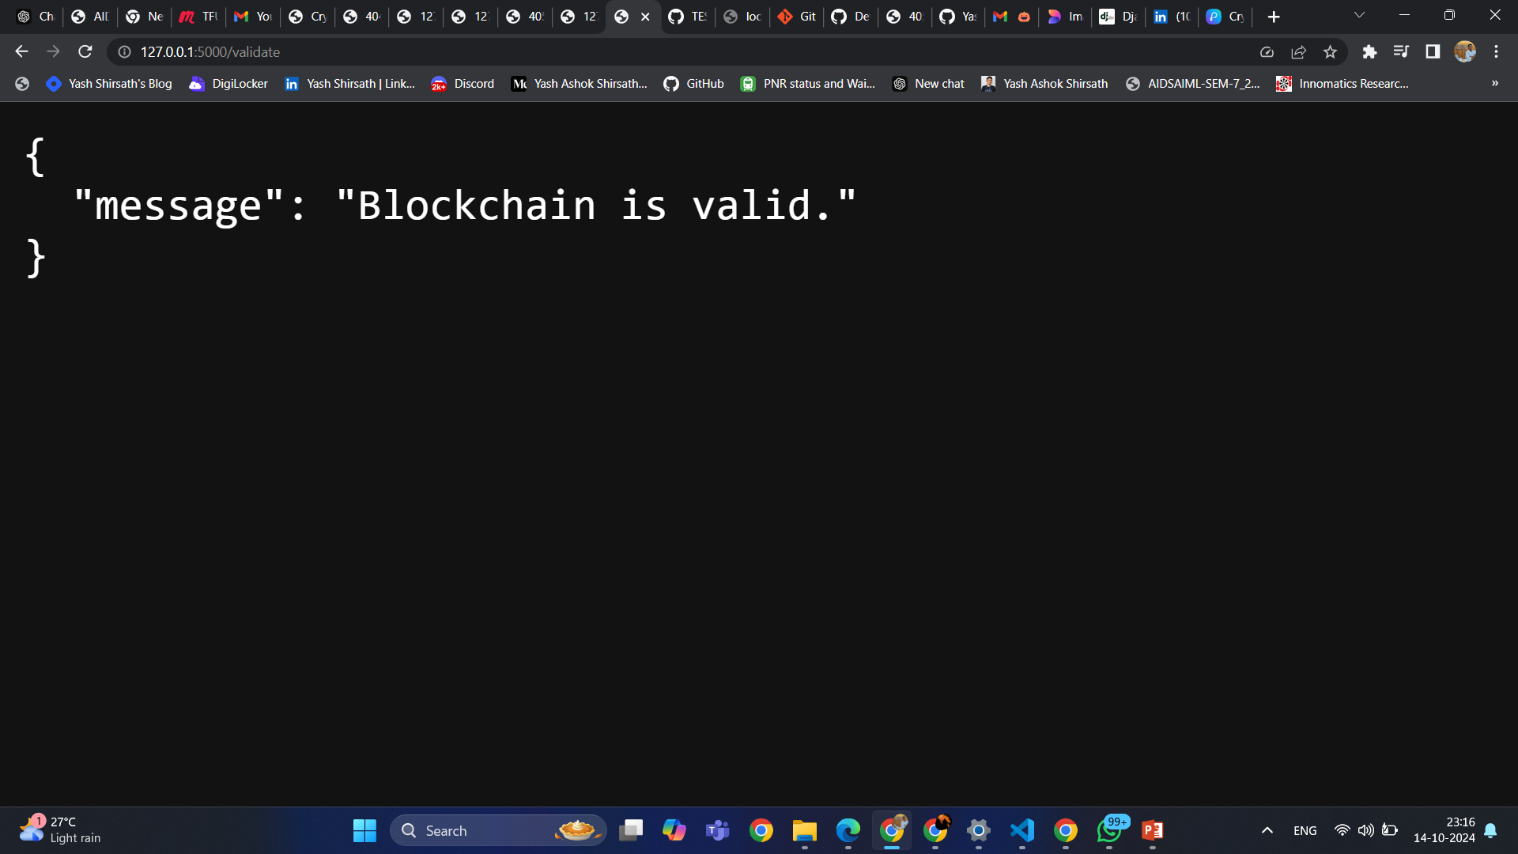

**Fig 3 - Validation**

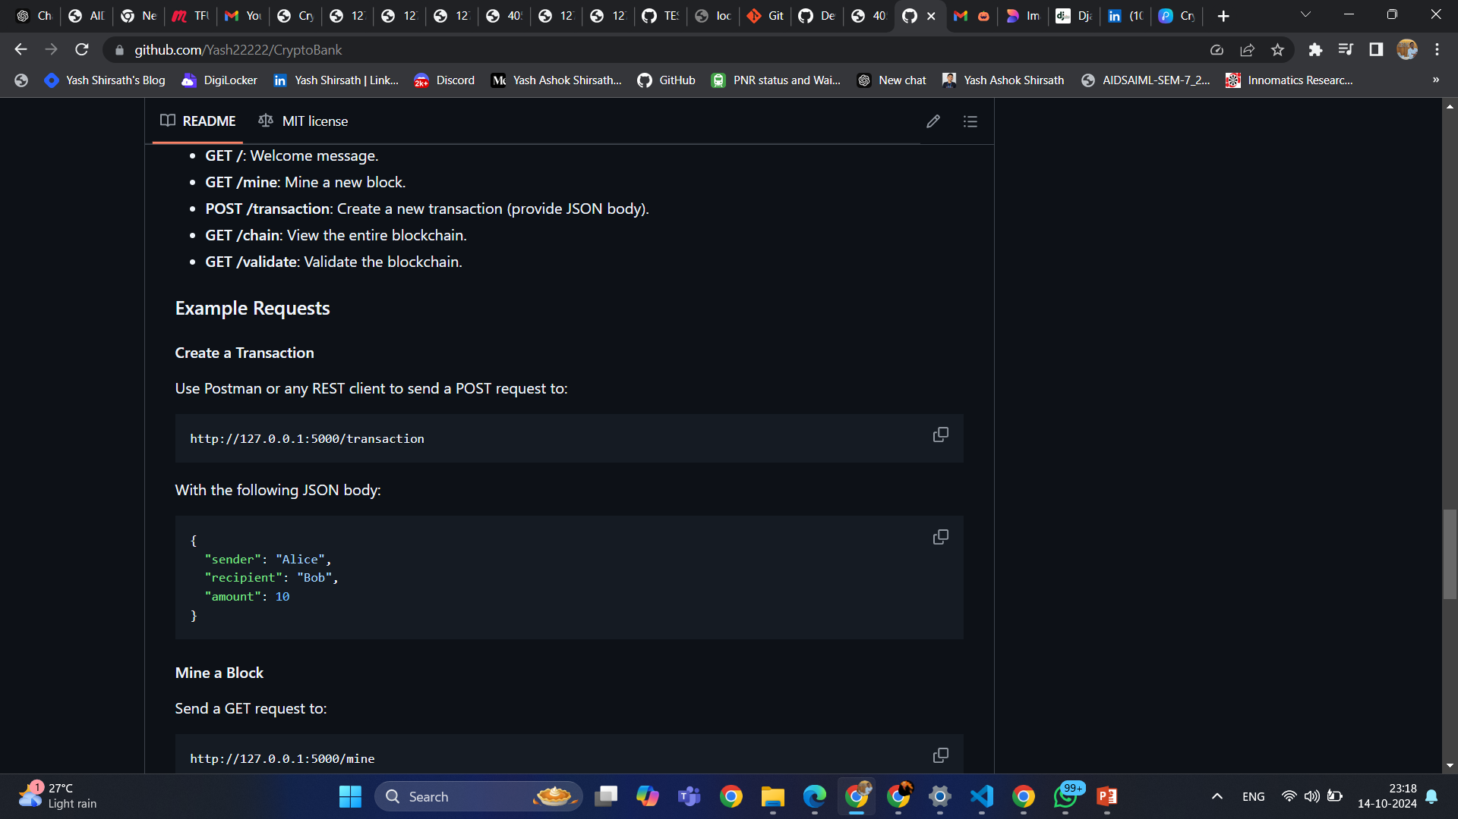

**Fig 4 - Addition**

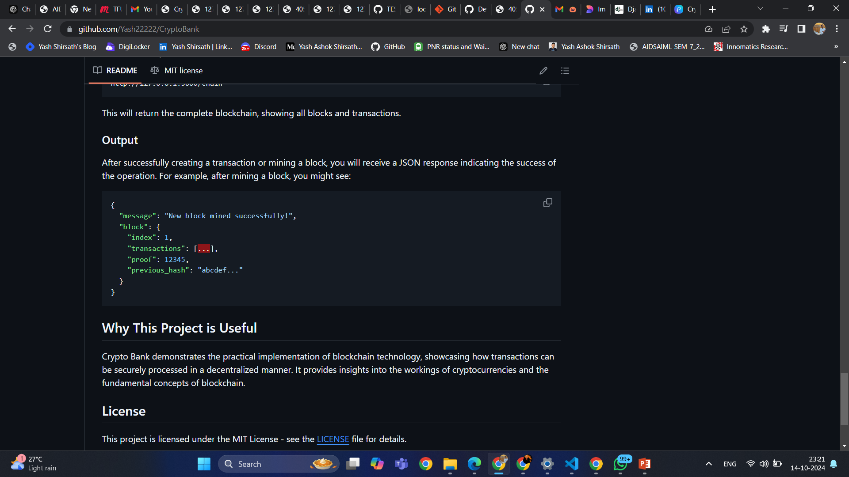

**Fig 5 - Block Addition/Mining**

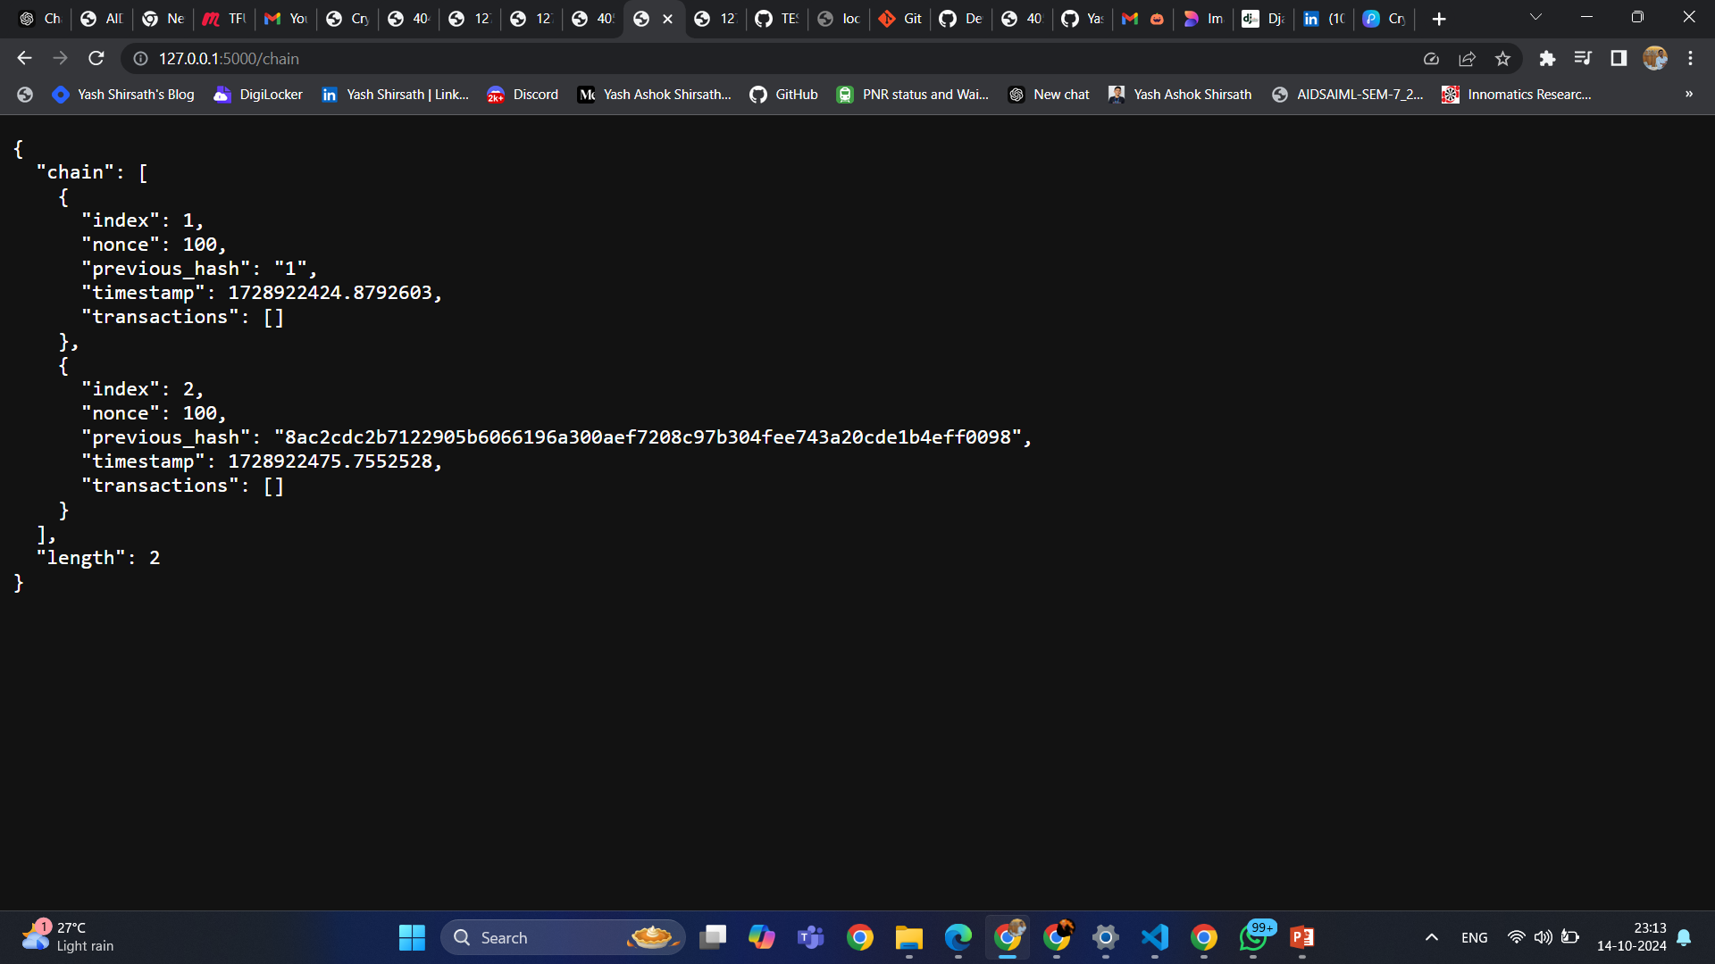

**Fig 6 - Chaining**

**3.6. Conclusion**

The Crypto Bank project effectively illustrates the application of blockchain technology in creating a decentralized financial platform. By utilizing core principles such as decentralization and security, the project enables secure transactions without intermediaries. with a Flask backend and React frontend, users can interact seamlessly with the blockchain, initiating transactions and validating the chain. The implementation of a Proof-of-Work algorithm ensures system integrity through consensus. overall, Crypto Bank serves as an educational tool and demonstrates the potential of blockchain to transform financial transactions, providing a secure and efficient alternative to traditional banking systems.

**3.7 References**

1. Nakamoto, S. (2008). Bitcoin: A Peer-to-Peer Electronic Cash System. Retrieved from bitcoin.org
2. Tapscott, D., & Tapscott, A. (2016). Blockchain Revolution: How the Technology Behind Bitcoin Is Changing Money, Business, and the World. Penguin.
3. Mougayar, W. (2016). The Business Blockchain: Promise, Practice, and the Application of the Next Internet Protocol. Wiley.
4. Buterin, V. (2014). "A Next-Generation Smart Contract and Decentralized Application Platform." Ethereum White Paper. Retrieved from ethereum.org
5. Zohar, A. (2015). "Bitcoin: Under the Hood." Communications of the ACM, vol. 58, no. 9, pp. 104–113. DOI: 10.1145/2752022